**VISVESVARAYA TECHNOLOGICAL UNIVERSITY**

Belgavi – 590014

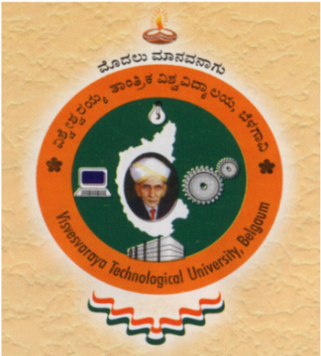

**Seminar Report on**

**“Title of the Seminar”**

*Submitted in the partial fulfillment of the requirements for the award of the Degree of*

***Bachelor of Engineering in Information Science and Engineering***

Submitted by

**Name of the student**

**USN**

Under the support and guidance of

**Name of the Guide**

**Designation of the Guide**

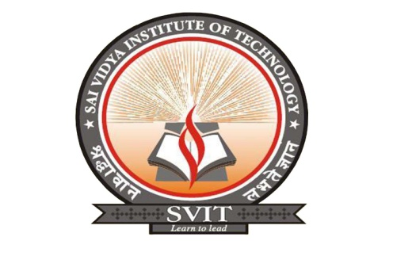

**DEPARTMENT OF Information SCIENCE & ENGINEERING**

**(Accredited by NBA,New Delhi), NAAC – “A” Grade**

**SAI VIDYA INSTITUTE OF TECHNOLOGY**

(Affiliated to VTU, Belgaum, Approved by AICTE, New Delhi and Govt. of Karnataka)

Rajanukunte,Bengaluru-560064

Tel: 080-2846 8196, Fax: 2846 8193 / 98, Web: saividya.ac.in

**2021-22**

**SAI VIDYA INSTITUTE OF TECHNOLOGY**

(Affiliated to VTU, Belgaum, Approved by AICTE, New Delhi and Govt. of Karnataka)

Rajanukunte,Bengaluru-560064

Department of Information Science and Engineering

**(Accredited by NBA,New Delhi), NAAC – “A” Grade**



**Certificate**

Certified that the Technical seminar (17ISS86) entitled **“Title of Seminar”**was presented by **Student Name (USN)**, a bonafide student of Sai Vidya Institute of Technology, Bangalore, in partial fulfillment for the award of Bachelor of Engineering in Information Science and Engineering of Visvesvaraya Technological University, Belgaum during the year 2018-2019.It is certified that all corrections/suggestions indicated for Internal Assessment have been incorporated in the report. The seminar report has been approved as it satisfies the academic requirements in respect of seminar work prescribed for the said degree.

**Name of the Guide Dr. Vrinda Shetty**

Seminar guide Professor & Head Principal

Assistant Professor Dept of ISE

Dept of ISE